1. The diagram shows the solid glass case for a clock. The case is a cuboid with a cylinder removed (to fit the clock mechanism). Calculate the volume of glass required to make the clock case. Use the picture on the next page to find the volume of a cylinder. (2 marks)

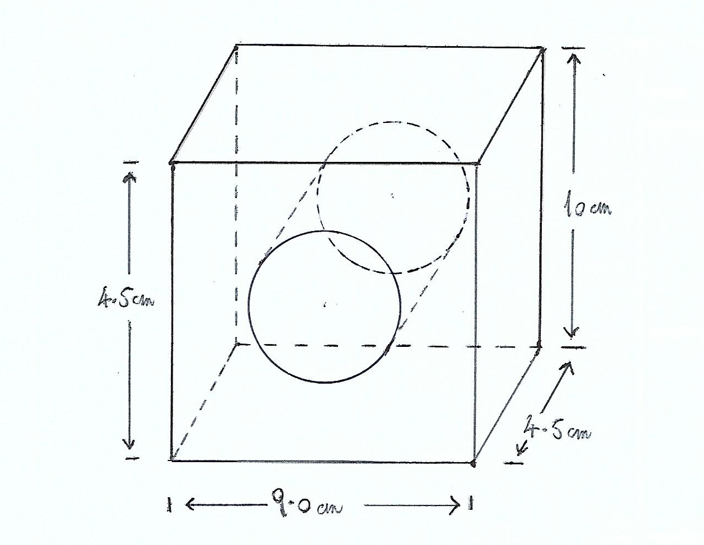

1. This is the outline of an ornamental garden. It consists of an equilateral triangle next to 3 semi-circles. Calculate the area. (2 marks)

Formulae: for the area of a circle, πr2, where r is the radius of a circle.

for the area of a triangle, ½ x base x height

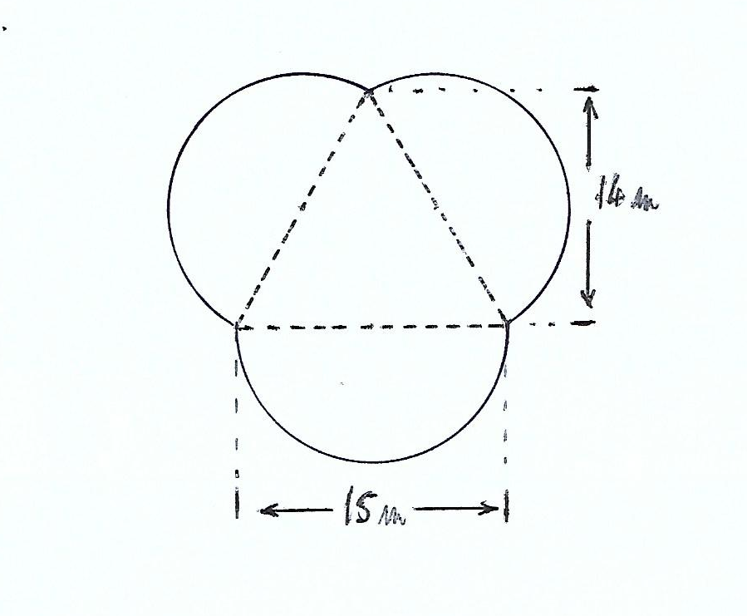

1. Imagine that the sphere and the cone shown in the pictures on the next page have the same volume. Find the radius of the sphere. (2 marks)

Height of cone: 7.2 cm

Radius of cone: 3.9 cm

The formulae are to be found with the pictures:

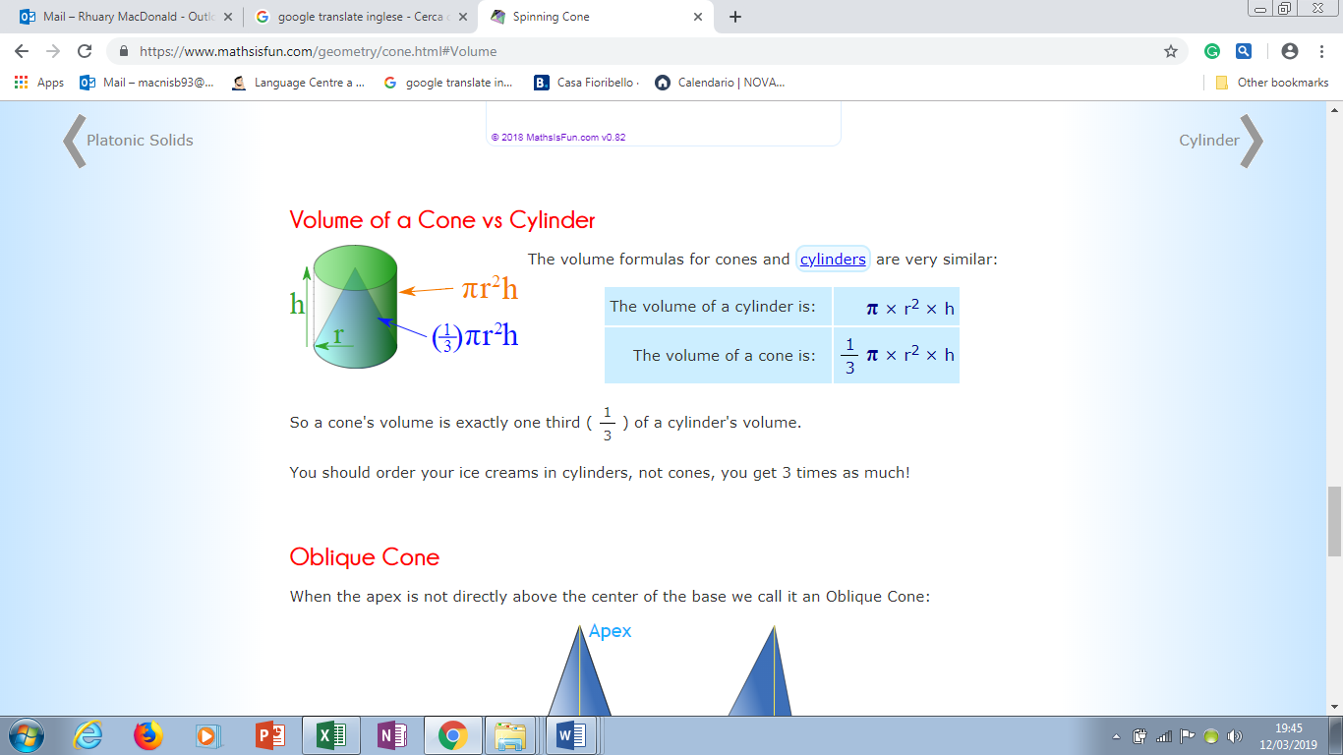

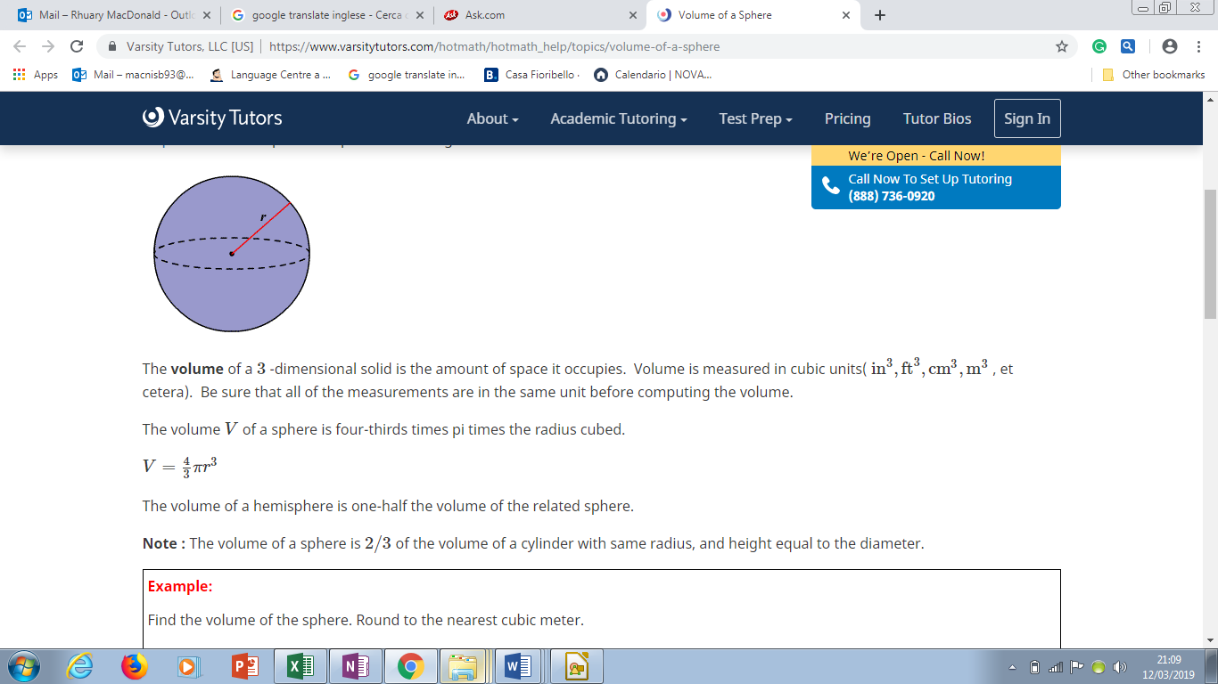

1. Robert and Iain each take a coin out of their pockets and add the totals together to get an amount. Robert has one £1 coin, two 50p coins, one 10p coin and one 5p coin. Iain has two 50p coins, two 10p coins and one 5p coin. £1.00 = 100p. (Total 5 marks)
2. Draw up a possibility diagram to show all the possible outcomes for the sum of the two coins.

(2 marks)

1. What is the probability that all the coins will add up to 60p? (1 mark)
2. What is the probability that all the coins will add up to 55p or less? (1 mark)
3. What is the probability that all the coins will add up to £1 or more? (1 mark)